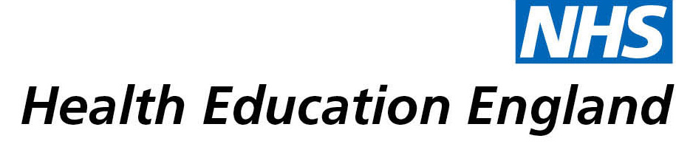

# Library and Knowledge Services case study

# *Nottinghamshire Healthcare NHS Foundation Trust: Intellectual and Developmental Disability Service (IDD) terminology consensus*

22nd April 2021

## Reason for enquiry

The Speech and Language Therapy (SLT) IDD service in the Trust frequently uses an approach aiming to support the communication of adults with intellectual disabilities called "Communication Profiles". This is similar to other approaches such as "Communication Passports". Although widely used there is confusion across the SLT profession (& wider ID services) around the terminology of these approaches and how they are used as an intervention. Some recent research suggested that having a Communication Passport was not effective at improving communication support.

Our service had been debating this issue as members of the Royal College of Speech & Language Therapists Adults with Learning Disabilities (RCSLT ALD) Leads Network and felt further work was needed to try to establish what evidence there was for these approaches and move towards a consensus for the terminology so both clinical practice and research used terms consistently.

Quote: "*The library service provides exceptional support to clinical staff who often do not have the time or ability to undertake the work. They are professional, efficient and helpful*."

## What the knowledge and library specialist did

As the starting point for the consensus work a literature search was needed to identify how the varied terms for Communication Profiles and associated approaches used clinically were reported in the literature. The aim was to establish any literature-based definitions and identify the evidence base for any of the individual approaches.

The library service supported me to develop a robust search strategy to capture the relevant information, ran the search and helped source relevant articles and books.

# Impact of input from the library and knowledge service

The literature search informed a UK wide consensus meeting (held in 2020) which produced SLT professional consensus descriptors for these approaches. These have been shared through regional and national networks and the write up has been submitted to the RCSLT professional practice magazine (Bulletin) and as an abstract for the RCSLT 2021 conference. It has also clarified the terminology we use in our service and sparked discussion about the key aspects of this approach which we feel are important to patient care.

## Immediate Impact

**Contributed to service development or delivery**

**Contributed to personal or professional developments**

Our Trust led on this work for the national ALD SLT leads network. It is positive for our reputation across the profession and supports recruitment and retention in a field which has significant recruitment challenges.

## Probable future Impact

**Improved the quality of patient care**

**More informed decision making**

The diversity of the formats and terminology in use for Communication Profiles and associated approaches means that research in this area is challenging since studies cannot be comparing like with like. Evidence in this area is urgently needed to support clinical decision making and high-quality care for patients. The consensus work which the literature searched informed is the first step in improving this.

## Submission by:

Siân Wood, Clinical Lead Speech and Language Therapist

## For further information on how you can get similar support contact your local NHS library and knowledge service.